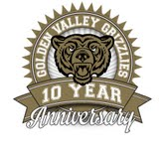
Golden Valley High School
Wm. S. Hart Union High School District
“Home of the Grizzlies”
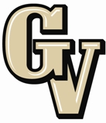

Parent Advisory Council (PAC) Meeting
March 23, 2015
6:30 PM

AGENDA

- PAC Meeting Welcome Joel Nelson

- Secretary’s Report ACTION Jennifer Ryan

- Treasurer’s Report ACTION Emily Curtis

- President’s Report Sue Alterman

- District Advisory Council (DAC) Report Colleen Villani

- Parent Communications Council (PCC) Report Suzanne Holmes

- CAASPP Testing Yvett Landeros

- English Learners Program Natalie Dickey

- Intervention Lesley Day

- ASB Claire Lee, ASB President

Announcements: - GV Open House 10 Year Celebration is 3/24/15
- Wind Ensemble and Symphonic Band SCSBOA Festival at West Ranch on 3/25 @ 4 pm
- ASVAB is 3/25/15
- SCVA Choir Festival at GVHS Theater at 4 pm
- Spaghetti Dinner for Choir on 3/26 in food court at 6 pm
- GV Football 2015 Parent meeting on 3/31 at 7 pm in the GV Theater
- Faculty Follies on April 1 @ 7 pm
- Spring Break April 6-10
- NHS Spring Induction on 4/15 at 6:30 in the GV Theater

Next Meeting: April 20, 2015

The mission of GVHS is to provide a quality education to a diverse student population, develop each student’s maximum potential, and prepare students for success in the global community.

